**MUFFAKHAM JAH COLLEGE OF ENGINEERING TECHNOLOGY**

(Affiliated to Osmania University)

Mount Pleasant, 8-2-249, Road No. 3, Banjara Hills, Hyderabad-34.



**DEPARTMENT OF INFORMATION TECHNOLOGY**

***CERTIFICATE***

This is to certify that the Mini Project work titled “**Help-Met [The life savior helmet]** ” is a bonafide work prescribed by the Osmania University for B.E III/IV IT V Semester during the academic year 2019-2020

Carried out by Syed Abdallah (1604-17-737-033)

Mohammed Yahya (1604-17-737-030)

Syed Muqeet Hassan (1604-17-737-040)

Course Coordinator Head-ITD Mohammed Riyazuddin Dr Mousmi Ajay Chaurasia

**Mini Project-III**

On

**HELP-MET**

**(The Life Savior Helmet)**

By

Syed Abdallah (1604-17-737-033)

Mohammed Yahiya (1604-17-737-030)

Syed Muqeeth Hasan (1604-17-737-040)

Of

B.E. (I.T.) III/IV V-Semester (CBCS) (A- Section)



**DEPARTMENT OF INFORMATION TECHNOLOGY**

**MUFFAKHAM JAH COLLEGE OF ENGINEERING AND TECHNOLOGY**

(Affiliated to Osmania University)

Mount Pleasant, 8-2-249,

Road No. 3, BanjaraHills,

Hyderabad-34.

**ACKNOWLEDGEMENT**

The austerity and satisfaction that one gets on completing a project cannot be fulfilled without mentioning the people who made it possible with gratitude.

We are grateful to the almighty God Allah who helped us all the way throughout the project and also has molded us into what we are today. We express our sincere thanks to our parents who encouraged us always to achieve our goals.

We offer our sincere thanks to Muffakham Jah College of Engineering and Technology for allowing us to do our mini project in their esteemed institution.

We show gratitude to **Dr. K. N. Krishnan sir, M.Tech, PhD** and **Principal** for having provided all the facilities and support. We would like to thank **Dr Mousmi Ajay Chaurasia,** (**Head of the Department, Information Technology)** for her expert guidance and encouragement at various level of project.

We are Thankful to our guide **Mr. Mohammed Riyazuddin** and **Mr. T.Nooruddin Ahmed** for his sustained inspiring Guidance and cooperation throughout the process of this project report.

We express our deep sense of gratitude and thanks to all the **Teaching** and **Non-Teaching Staff** of our college who stood with us and helped us to make it a successful venture.

**ABSTRACT**

Workers in mines and in other dangerous working areas like sewer canals, manholes, are risking their health and life every day! Mining is one of the most dangerous trades in the world. Miners deal every day with dangerous gases and high temperature levels in a dark environment. With the help of Arduino we designed and developed a Smart Working Helmet that can save their lives, if something goes wrong.

The HELP-MET Arduino Smart Helmet is using the Arduino board to read values from gas sensor, temperature sensor and light sensor. It has three main abilities:

* If the worker is approaching to a dangerous gas, the helmet will inform him with a warning sound from the buzzer. If the environment is too noisy, he will know that he is in danger by the red blinking led in the front of the helmet. The warning sound and the red led will repeated faster as he is approaching closer to a dangerous environment.
* If the environment temperature becomes higher than the worker's body can withstand (e.g. 50 ºC), the helmet will inform him with a (different) warning sound from the buzzer. If the environment is too noisy, he will know that he is in danger from the red blinking led in the front of the helmet.
* If the working environment becomes darker, the helmet's front light will be turned on. It has a rechargeable battery and can be easily re-programmed to adjust values of the working environment.

**CONTENTS**

1. **Introduction**
2. **Requirement Specification**
3. **System Design**

**3.1 System Architecture**

**3.2 Basic Structure**

**3.3 Interface**

1. **Flowchart**
2. **Code**
3. **Screenshots**
4. **Conclusion** & **Future Enhancement**
5. **Bibliography**

**CHAPTER 1**

**INTRODUCTION**

**INTRODUCTION**

The most important part of any type of industry is safety. In the mining industry safety and security is a first aspect of all. To avoid any types of unwanted conditions, every mining industry follows some basic precaution. There are many risk factors such as harmful gases and high temperature and much more ,to monitor different parameters such as, gas, and helmet remover continuously using sensors such as collision sensor, gas sensor MQ2 and Helmet sensor to take necessary actions accordingly to avoid any types of hazardous conditions and gives an alert using buzzer. To achieve safety in underground mines.

India is a country, which is renowned for its extensive and distinct mineral reserves and big mining businesses. India produces about eighty eight minerals, out of which it has four minerals related to fuel, ten minerals that is of kind metals, fifty minerals that is of non-metallic in nature and remaining twenty four includes minor minerals. As of 2014 Apr India has over three hundred Billion Tonnes coal holds. Generation of coal in the year 2012 and 2014 remained at five hundred and forty Million Tonnes and five hundred and fifty seven Million Tonnes respectively. In mining industry personnel casualty of workers is common. Supervisors will be held accountable for all the wounds that take place below their management, and thus they need to consider the probable unsafe circumstances. The issue that we are addressing in this work is to develop a prototype of a safety helmet so as to assure extra safety alertness among mine workers. At the point while they are on job with machinery which produces loud noise, being alert to ones surroundings will typically be difficult. In the mining work place, the workers lean towards taking out several of their safety accessories as the accessory may be too weighty, hot or annoying to work with. The mining helmet is one of the safety

Accessories which they never tend to remove. The mining helmets have no intelligence adjoined to it to let workers know when he or his associate worker has experienced a dangerous event. In this way the motivation of the project is to specialize a current protective helmet for mine workers to make it still safer and technologically advanced by including a sensors, microcontrollers

**CHAPTER 2**

**Requirement Specification**

**REQUIREMENT SPECIFICATIONS**

**Software Requirements:**

* Arduino IDE

A Basic computer system with minimum requirements for Arduino Studio:

* Operating System: Windows 8 and above versions, Mac, Linux.
  + RAM : 4GB and above.
  + ROM : 500GB and above.
  + Processor : i5 and above

**Hardware Requirements:**

* Plastic helmet
* Micro Controller
* MQ2 Gas Sensor
* Temperature Sensor
* LED’S
* Buzzer
* Connecting Wires
* And other miscellaneous

**CHAPTER 3**

**SYSTEM DESIGN**

**3.1 SYSTEM ARCHITECTURE**

The Architecture of the proposed system is the design diagram which depicts the scope of the project with the whole system design. In architecture diagram, it highlights the modules with its various functions as a process. It aims to convey the internal design of the proposed system the following Figure shows the entire architecture of the proposed system.

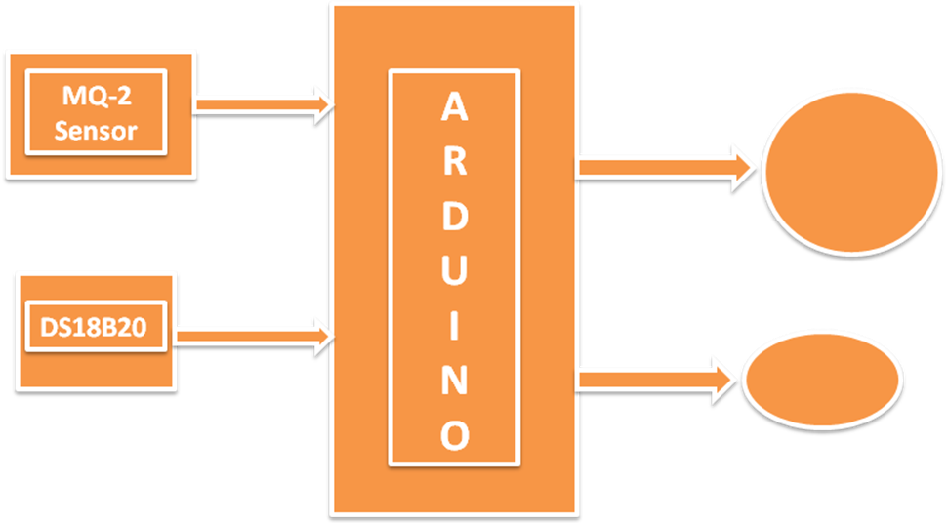

***MQ2***

MQ2 is one of the commonly used gas sensors in MQ sensor series. It is a Metal Oxide Semiconductor (MOS) type Gas Sensor also known as **Chemiresistors** as the detection is based upon change of resistance of the sensing material when the Gas comes in contact with the material. Using a simple voltage divider network, concentrations of gas can be detected.

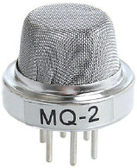

MQ2 Gas sensor works on 5V DC and draws around 800mW. It can detect **LPG**, **Smoke**, **Alcohol**, **Propane**, **Hydrogen**, **Methane** and **Carbon Monoxide**concentrations anywhere from 200 to 10000ppm.

**DS18B20**

The DS18B20 digital thermometer provides 9-bit to 12-bit Celsius temperature measurements and has an alarm function with nonvolatile user-programmable upper and lower trigger points. The DS18B20 communicates over a 1-Wire bus that by definition requires only one data line (and ground) for communication with a central microprocessor. In addition, the DS18B20 can derive power directly from the data line ("parasite power"), eliminating the need for an external power supply.

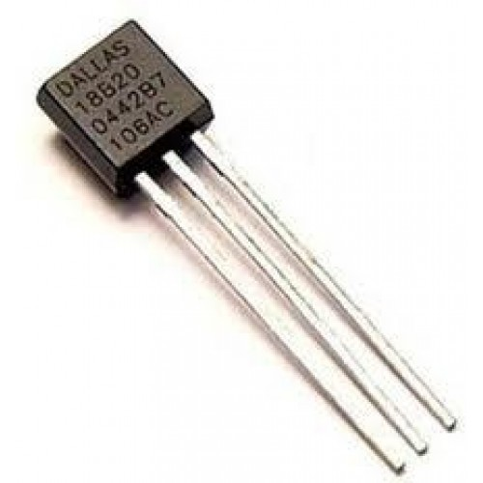

Each DS18B20 has a unique 64-bit serial code, which allows multiple DS18B20s to function on the same 1-Wire bus. Thus, it is simple to use one microprocessor to control many DS18B20s distributed over a large area. Applications that can benefit from this feature include HVAC environmental controls, temperature monitoring systems inside buildings, equipment, or machinery, and process monitoring and control systems.

*The****Arduino Uno****is an*[*open-source*](https://en.wikipedia.org/wiki/Open-source)[*microcontroller board*](https://en.wikipedia.org/wiki/Microcontroller_board)*based on the*[*Microchip*](https://en.wikipedia.org/wiki/Microchip_Technology)[*ATmega328P*](https://en.wikipedia.org/wiki/ATmega328P)*microcontroller and developed by*[*Arduino.cc*](https://en.wikipedia.org/wiki/Arduino)*. The board is equipped with sets of digital and analog*[*input/output*](https://en.wikipedia.org/wiki/Input/output)*(I/O) pins that may be interfaced to various*[*expansion boards*](https://en.wikipedia.org/wiki/Expansion_board)*(shields) and other circuits.*[*[1]*](https://en.wikipedia.org/wiki/Arduino_Uno#cite_note-Makerspace-1)*The board has 14 Digital pins, 6 Analog pins, and programmable with the*[*Arduino IDE*](https://en.wikipedia.org/wiki/Arduino#Software)*(Integrated Development Environment) via a type B*[*USB cable*](https://en.wikipedia.org/wiki/USB_cable)*. It can be powered by the USB cable or by an external*[*9-volt battery*](https://en.wikipedia.org/wiki/9-volt_battery)*, though it accepts voltages between 7 and 20 volts. It is also similar to the*[*Arduino Nano*](https://en.wikipedia.org/wiki/Arduino_Nano)*and Leonardo.*

# 

# *Arduino UNO R3 Clone - With USB Cable - (USB Chip CH340)*

**CHAPTER 4**

**FLOWCHART**

FLOWCHART

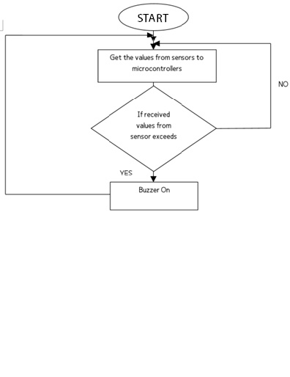

**CHAPTER 5**

**CODE**

**CODE**

#include <OneWire.h>

#include <DallasTemperature.h>

//Contants

const int pResistor = A0; // Photoresistor pin to Arduino analog A1 pin

const int buzzer= 7; // Buzzer pin to Arduino pin 7

const int gasSensor= A1; // Gas sensor MQ-2 signal pin to Arduino analog A0 pin

const int hLight= 8; // Helmet light to Arduino pin 4

const int redLed=9; // Red led pin to Arduino pin 5

/* Temp sensor DS18B20 to Arduino pin 2 */

#define ONE_WIRE_BUS 11

OneWire oneWire(ONE_WIRE_BUS);

DallasTemperature sensors(&oneWire);

/* Change values if you want */

////////////////////

int dTemp = 35; // Default temperature

int dGas = 400; // Default Air value (0-1023)

int bValue= 10; // Brightness value (0-1023)

///////////////////

//Variables

int gasValue;

int lightValue;

int tempValue;

void setup(void)

{

//Serial monitor setup

//Serial.begin(9600);

pinMode(buzzer,OUTPUT);

pinMode(hLight,OUTPUT);

pinMode(redLed, OUTPUT);

sensors.begin();

delay(10000);//mq-2 warmup delay (60sec)

}

void loop(void)

{

// Read and store values to aditional variables

gasValue = analogRead(gasSensor);

lightValue = analogRead(pResistor);

sensors.requestTemperatures();

tempValue = sensors.getTempCByIndex(0); // Why "byIndex"? You can have more than one IC on the same bus. 0 refers to the first IC on the wire

Serial.print(gasValue); Serial.print(" ");

Serial.print(lightValue);Serial.print(" ");

Serial.println(tempValue);

// Dangerous gas if

if (gasValue >= dGas+100 && gasValue < dGas+200){

//tone(buzzer, 1000);

police();

digitalWrite(redLed,HIGH);

delay(150);

// tone(buzzer, 350);

police();

digitalWrite(redLed,LOW);

delay(150);

}

else if (gasValue >= dGas+200 && gasValue < dGas+300){

//tone(buzzer, 1000);

police();

digitalWrite(redLed,HIGH);

delay(100);

police();

digitalWrite(redLed,LOW);

delay(100);

}

else if (gasValue >= dGas+300 && gasValue < dGas+400){

police();

digitalWrite(redLed,HIGH);

delay(75);

police();

digitalWrite(redLed,LOW);

delay(75);

}

else if (gasValue >= dGas+400 && gasValue < dGas+500){

police();

digitalWrite(redLed,HIGH);

delay(50);

police();

digitalWrite(redLed,LOW);

delay(50);

}

else if (gasValue >= dGas+500 && gasValue < dGas+600){

tone(buzzer, 1000);

digitalWrite(redLed,HIGH);

delay(25);

police();

digitalWrite(redLed,LOW);

delay(25);

}

else if (gasValue >= dGas+600){

police();

digitalWrite(redLed,HIGH);

}

else if (tempValue < dTemp+15 ){

noTone(buzzer);

digitalWrite(redLed,LOW);

}

else{}

// High temperature

if (tempValue >= dTemp+15 && tempValue<16 ){

tone(buzzer, 600);

digitalWrite(redLed, HIGH);

delay(150);

tone(buzzer, 250);

digitalWrite(redLed, LOW);

delay(150);

}

else if (tempValue >= dTemp+16 && tempValue<17){

tone(buzzer, 600);

digitalWrite(redLed, HIGH);

delay(125);

tone(buzzer, 250);

digitalWrite(redLed, LOW);

delay(125);

}

else if (tempValue >= dTemp+17 && tempValue<18){

tone(buzzer, 600);

digitalWrite(redLed, HIGH);

delay(100);

tone(buzzer, 250);

digitalWrite(redLed, LOW);

delay(100);

}

else if (tempValue >= dTemp+18 && tempValue<19){

tone(buzzer, 600);

digitalWrite(redLed, HIGH);

delay(75);

tone(buzzer, 250);

digitalWrite(redLed, LOW);

delay(75);

}

else if (tempValue >= dTemp+19){

tone(buzzer, 600);

digitalWrite(redLed, HIGH);

}

else if(gasValue <= 700){

noTone(buzzer);

digitalWrite(redLed, LOW);

}

else {}

// Room/area light - brightness

if (lightValue > bValue){

digitalWrite(hLight, LOW);

}

else{

digitalWrite(hLight, HIGH);

}

}

void police()

{

int i=0;

for(i=700;i<800;i++){

tone(buzzer,i);

delay(15);

}

for(i=800;i>700;i--){

tone(buzzer,i);

delay(15);

}

}

**CHAPTER 6**

**SCREEN SHOTS**

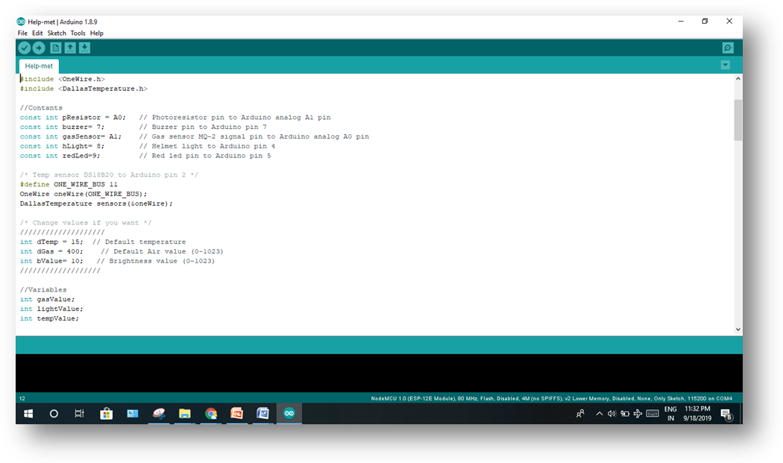

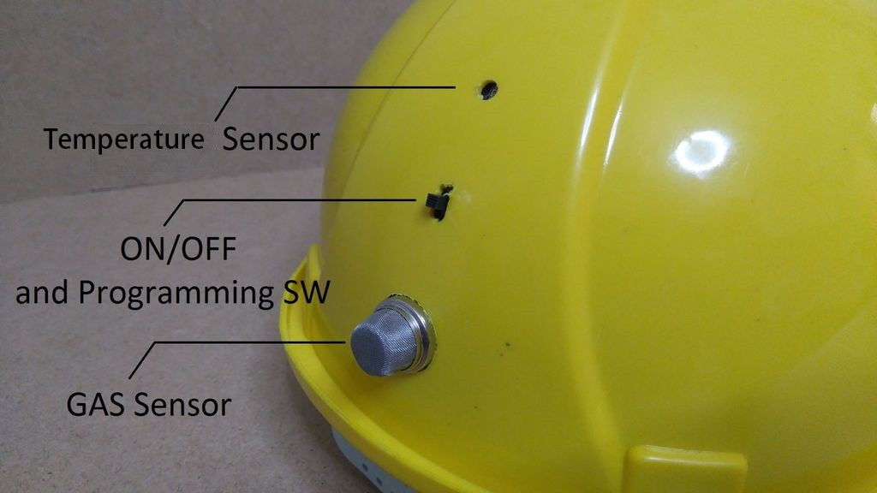

**CHAPTER 7**

**Conclusion** & **Future Enhancement**

A prototype of smart helmet is developed to detect various types of dangerous event such as air quality, miner removing the safety helmet and collision on miner head and send this dangerous event information towards the monitoring section which provides rescue operation for the miner. The present Mine security system can be effectively replaced by using this rescue safety system. This system covered the most Important and Primary necessity aspect of any mine workers safety. The monitoring of depth and dangerous mines is made easy with this paper. In this paper we used Low power RF transmission and receiver. All the sensors can be easily place on helmet that helps in continuous monitoring.

**CHAPTER 8**

**BIBLIOGRAPHY**

**BIBLIOGRAPHY**

* [1] E. K. Stanek, “Mine Electrotechnology Research: The Past 17 Years”, IEEE transactions on industry applications, vol. 24(5), pp 818-19, 1988. [2] S. Wei, L. Li-li, “Multi-parameter Monitoring System for Coal Mine based on Wireless Sensor Network Technology”, Proc. International IEEE Conference on Industrial Mechatronics and Automation, pp 225-27, 2009.